Requirements
Find a prob
ask people about it
Focus on about what aspects of design are causing problems

SDGs
Responsible Consumption and Production
Good Health and Well-being
Sustainable Cities and Communities

Title: Proposal
Motivation: Good Health and Well-being
Problem Statement:
How might we improve <adjectiveness> of <verb>-ing?
How might we make <verbing> more <adjective> for target <users>?
References
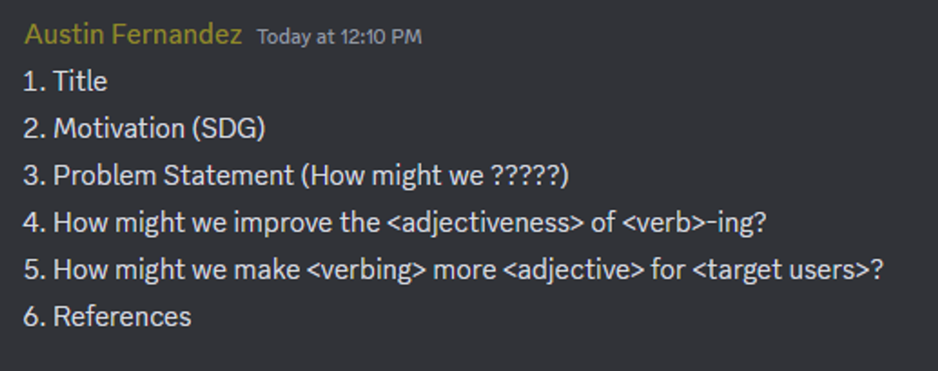
Potential problems:

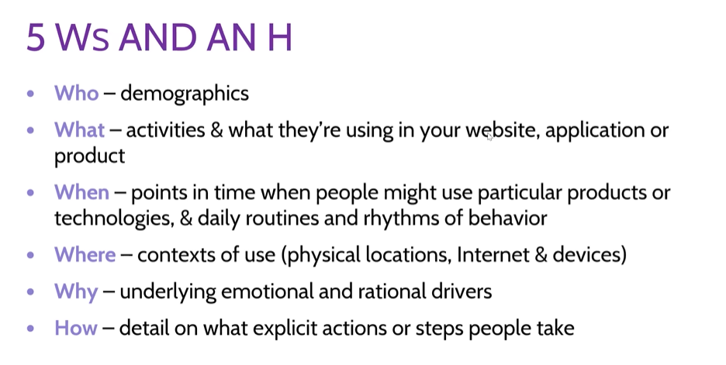

Problem | Problem Statement
Software Application brightness and oversaturated color schemes, fonts, and etc. may affect user’s physical health for those with certain eye/brain conditions. (visuals) | How might we make make software services
Software services lack accessibility for those with disabilities or of old age (font sizes, color blindness, brightness)
Software application layout, how and when information is given, and visuals have the ability to manipulate users into forming unhealthy habits (like gambling websites, social media websites) (layout design)
Software designs encouraging unhealthy or dangerous posture or physical actions (ex. Carpal tunnel)
Software services subtly encouraging unhealthy diets due to ad traffic and how this contributes to public health

Who is our
What
Where
How

